# Database Basics MS SQL Exam – 16 Apr 2019

Exam problems for the [“Database Basics” course @ SoftUni](https://softuni.bg/courses/databases-basics-ms-sql-server).

Submit your solutions in the SoftUni Judge system at <https://judge.softuni.bg/>

# Airport

# Section 1. DDL (30 pts)

You are given an E/R Diagram of the Airport:

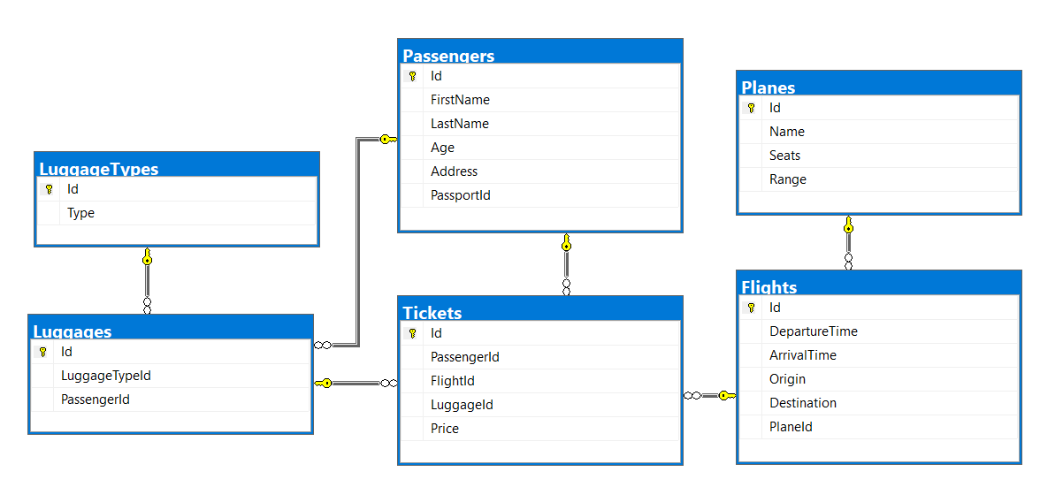

Crеate a database called Airport. You need to create **6 tables**:

* Planes – contains information about the **planes**.
* Flights – contains information about the **flights**.
* Passеngers – contains information about the **passengers**
* LuggageTypes – contains information about the **type of luggage's**.
* Flights – contains information about the **flights**.
  + Each flight has a plane.
* Luggages – contains information about the **luggage's**.
  + Each luggage has a luggage type.
* Tickets – contains information about the tickets.
  + Each ticket has a passenger.
  + Each ticket has a flight.
  + Each ticket has a luggage.

**Planes**

|  |  |  |
| --- | --- | --- |
| **Column Name** | **Data Type** | **Constraints** |
| Id | **Integer** from **0** to **2,147,483,647** | Unique table **identificator**, **Identity** |
| Name | **String** up to 30 symbols | **NULL** is **not** allowed |
| Seats | **Integer** from **0** to **2,147,483,647** | **NULL** is **not** allowed |
| Range | **Integer** from **0** to **2,147,483,647** | **NULL** is **not** allowed |

**Flights**

|  |  |  |
| --- | --- | --- |
| **Column Name** | **Data Type** | **Constraints** |
| Id | **Integer** from **0** to **2,147,483,647** | Unique table **identificator**, **Identity** |
| DepartureTime | **Datetime** | None |
| ArrivalTime | **Datetime** | None |
| Origin | **String** up to 50 symbols | **NULL** is **not** allowed |
| Destination | **String** up to 50 symbols | **NULL** is **not** allowed |
| PlaneId | **Integer** from **0** to **2,147,483,647** | **NULL** is **not** allowed, Relationship with table Planes |

**Passengers**

|  |  |  |
| --- | --- | --- |
| **Column Name** | **Data Type** | **Constraints** |
| Id | **Integer** from **0** to **2,147,483,647** | Unique table **identificator**, **Identity** |
| FirstName | **String** up to 30 symbols | **NULL** is **not** allowed |
| LastName | **String** up to 30 symbols | **NULL** is **not** allowed |
| Age | **Integer** from **0** to **2,147,483,647** | **NULL** is **not** allowed |
| Address | **String** up to 30 symbols | **NULL** is **not** allowed |
| PassportId | **String** with **exactly 11** symbols | **NULL** is **not** allowed |

**LuggageTypes**

|  |  |  |
| --- | --- | --- |
| **Column Name** | **Data Type** | **Constraints** |
| Id | **Integer** from **0** to **2,147,483,647** | Unique table **identificator**, **Identity** |
| Type | **String** up to 30 symbols | **NULL** is **not** allowed |

**Luggages**

|  |  |  |
| --- | --- | --- |
| **Column Name** | **Data Type** | **Constraints** |
| Id | **Integer** from **0** to **2,147,483,647** | Unique table **identificator**, **Identity** |
| LuggageTypeId | **Integer** from **0** to **2,147,483,647** | **NULL** is **not** allowed, Relationship with table **LuggageTypes** |
| PassengerId | **Integer** from **0** to **2,147,483,647** | **NULL** is **not** allowed, Relationship with table **Passengers** |

**Tickets**

|  |  |  |
| --- | --- | --- |
| **Column Name** | **Data Type** | **Constraints** |
| Id | **Integer** from **0** to **2,147,483,647** | Unique table **identificator**, **Identity** |
| PassеngerId | **Integer** from **0** to **2,147,483,647** | **NULL** is **not** allowed, Relationship with table **Passengers** |
| FlightId | **Integer** from **0** to **2,147,483,647** | **NULL** is **not** allowed, Relationship with table **Flights** |
| LuggageId | **Integer** from **0** to **2,147,483,647** | **NULL** is **not** allowed, Relationship with table **Luggages** |
| Price | **Decimal** number with **two-digit** precision | **NULL** is **not** allowed |

## Database Design

Submit all of yours **create** **statements** to Judge (only creation of tables).

# Section 2. DML (10 pts)

**Before you start, you must import “**DataSet-Airport.sql**”. If you have created the structure correctly, the data should be successfully inserted without any errors.**

In this section, you have to do some data manipulations:

## Insert

**Insert** some sample data into the database. Write a query to add the following records into the corresponding tables. **All Ids should be auto-generated**.

**Planes**

|  |  |  |
| --- | --- | --- |
| Name | Seats | Range |
| Airbus 336 | 112 | 5132 |
| Airbus 330 | 432 | 5325 |
| Boeing 369 | 231 | 2355 |
| Stelt 297 | 254 | 2143 |
| Boeing 338 | 165 | 5111 |
| Airbus 558 | 387 | 1342 |
| Boeing 128 | 345 | 5541 |

**Luggage Types**

|  |
| --- |
| Type |
| Crossbody Bag |
| School Backpack |
| Shoulder Bag |

## Update

Make all flights to "**Carlsbad**" 13% more expensive.

## Delete

Delete all flights to "**Ayn Halagim**".

# Section 3. Querying (40 pts)

**You need to start with a fresh dataset, so recreate your DB and import the sample data again (**DataSet-Bitbucket.sql**).**

## Trips

Select all **flights** from the database. Order them by **origin** (ascending) and **destination** (ascending).

### Examples

|  |  |
| --- | --- |
| **Origin** | **Destination** |
| Abelheira | Sabanitas |
| Adirejo | Koblain |
| Alfena | Makariv |
| Aubagne | Kitahama |
| … | … |

## The "Tr" Planes

Select all of the **planes,** which name contains "**tr**". Order them by **id** (ascending), **name** (ascending), **seats** (ascending) and **range** (ascending).

### Examples

|  |  |  |  |
| --- | --- | --- | --- |
| **Id** | **Name** | **Seats** | **Range** |
| 31 | Trunyx cpp | 195 | 2653 |
| 86 | Yakitri | 321 | 1360 |
| 87 | Trilith | 223 | 4375 |
| … | … | … | … |

## Flight Profits

Select the total profit for each flight from database. Order them by **total price** (descending), **flight id** (ascending).

### Examples

|  |  |
| --- | --- |
| **FlightId** | **Price** |
| 58 | 828.43 |
| 43 | 819.84 |
| … | … |

## Passengers and Prices

Select top 10 records from passengers along with the price for their tickets. Order them by price (descending), first name (ascending) and last name (ascending).

### Examples

|  |  |  |
| --- | --- | --- |
| **FirstName** | **LastName** | **Price** |
| Brittne | Leggin | 447.82 |
| Adolphe | Juste | 440.12 |
| Rudyard | Kaveney | 439.96 |
| … | … | … |

## Most Used Luggage's

### Examples

Select luggage type and how many times was used by persons. Sort by count (descending) and luggage type (ascending).

|  |  |
| --- | --- |
| **Type** | **MostUsedLuggage** |
| Garment Bag | 19 |
| Wheeled Business Case | 19 |
| Duffel Bag | 16 |
| … | .. |

## Passenger Trips

Select the full name of the passengers with their trips (origin - destination). Order them by **full name** (ascending), **origin** (ascending) and **destination** (ascending).

### Examples

|  |  |  |
| --- | --- | --- |
| **Full Name** | **Origin** | **Destination** |
| Adina Uvedale | Lawa-an | Hulei |
| Adolphe Juste | Boto | Pantubig |
| Adolphe Juste | Codrington | Kasiyan |
| … | … | .. |

## Non Adventures People

Select all people who don't have tickets. Select their first name, last name and age .Order them by **age** (descending), **first name** (ascending) and **last name** (ascending).

### Examples

|  |  |  |
| --- | --- | --- |
| **First Name** | **Last Name** | **Age** |
| Felipa | Wabe | 89 |
| Darius | Ellissen | 87 |
| Eleen | Ummfrey | 86 |
| … | … | .. |

## Lost Luggage's

Select all passengers who don't have luggage's. Select their passport id and address. Order the results by **passport id** (ascending) and **address** (ascending).

### Examples

|  |  |
| --- | --- |
| **Passport Id** | **Address** |
| 105-40-7273 | 4 Haas Park |
| 135-11-2922 | 435 Marquette Terrace |
| 165-12-7011 | 2056 Kedzie Pass |
| … | .. |

## Count of Trips

Select all passengers and their count of trips. Select the first name, last name and count of trips. Order the results by total trips (descending), **first name** (ascending) and **last name** (ascending).

### Examples

|  |  |  |
| --- | --- | --- |
| **First Name** | **Last Name** | **Total Trips** |
| Adolphe | Juste | 5 |
| Neddie | Hugill | 4 |
| Ashley | Peterkin | 3 |
| … | … | .. |

## Full Info

Select all passengers who have trips. Select their full name (first name – last name), plane name, trip (in format {origin} - {destination}) and luggage type. Order the results by **full name** (ascending), **name** (ascending), **origin** (ascending), **destination** (ascending) and **luggage type** (ascending).

### Examples

|  |  |  |  |
| --- | --- | --- | --- |
| **Full Name** | **Plane Name** | **Trip** | **Luggage Type** |
| Adina Uvedale | Feedspan | Lawa-an - Hulei | Wheeled Business Case |
| Adolphe Juste | Babbleopia | Usagara - Ikhtiman | Upright Luggage |
| Adolphe Juste | Feednation | Le Mans - Grazhdanka | Duffel Bag |
| … | … | … | … |

## Most Expensive Trips

Select all passengers who have flights. Select their first name, last name, destination and price for the ticket. Take only the ticket with highest price for user. Order the results by price (descending), first name (ascending), last name (ascending) and destination (ascending).

### Examples

|  |  |  |  |
| --- | --- | --- | --- |
| **First Name** | **Last Name** | **Destination** | **Price** |
| Brittne | Leggin | Quitilipi | 447.82 |
| Adolphe | Juste | Pantubig | 440.12 |
| Rudyard | Kaveney | Kynopiastes | 439.96 |
| … | … | … | … |

## Destinations Info

Select all destinations and trips count to them. Sort the result by trips count (descending) and destination name (ascending).

### Examples

|  |  |
| --- | --- |
| **Destination** | **FilesCount** |
| Daniwato | 3 |
| Kobenhavn | 3 |
| San Lorenzo | 3 |
| … | … |

## PSP

Select all planes with their name, seats count and passengers count. Order the results by passengers count (descending), plane name (ascending) and seats (ascending)

### Examples

|  |  |  |
| --- | --- | --- |
| **Name** | **Seats** | **Passengers Count** |
| Jabberbean | 56 | 3 |
| Jabberstorm | 271 | 3 |
| Linkbuzz | 230 | 3 |
| … | … | … |

# Section 4. Programmability (20 pts)

## Vacation

Create a **user defined function**, named **udf_CalculateTickets(@origin, @destination, @peopleCount)** that receives an origin (town name), destination (town name) and people count.

The function must return the total price in format "**Total price {price}**"

* If people count is less or equal to zero return – "**Invalid people count!**"
* If flight is invalid return – "**Invalid flight!**"

### Example:

|  |
| --- |
| **Query** |
| **SELECT** **dbo.udf_CalculateTickets**(**'Kolyshley'**,**'Rancabolang'**, **33**) |
| **Output** |
| **Total price 2419.89** |

|  |
| --- |
| **Query** |
| **SELECT** **dbo.udf_CalculateTickets**(**'Kolyshley'**,**'Rancabolang'**, **-1**) |
| **Output** |
| **Invalid people count!** |

|  |
| --- |
| **Query** |
| **SELECT** **dbo.udf_CalculateTickets**(**'Invalid'**,**'Rancabolang'**, **33**) |
| **Output** |
| **Invalid flight!** |

## Wrong Data

Create a **user defined stored procedure**, named **usp_CancelFlights**  
The procedure must cancel all flights on which the arrival time is before the departure time. Cancel means you need to leave the departure and arrival time empty.

### Example:

|  |
| --- |
| **Query** |
| **EXEC** **usp_CancelFlights** |
| **Output** |
| (49 rows affected) |

## Deleted Planes

Create a new table **"DeletedPlanes**" with columns **(Id,Name,Seats, Range)**. Create a **trigger**, which fires when planes are deleted. After deleting the planes, **insert all of the data into the new table** "**DeletedPlanes"**.

Note: Submit only your **CREATE TRIGGER** statement!

### Example usage:

|  |
| --- |
| **Query** |
| **DELETE** **Tickets**  **WHERE** **FlightId** **IN** (**SELECT** **Id** **FROM** **Flights** **WHERE** **PlaneId** = **8**) **DELETE** **FROM** **Flights**  **WHERE** **PlaneId** **= 8**  **DELETE** **FROM** **Planes**  **WHERE** **Id** **= 8** |
| **Response** |
| **(1 rows affected)**  **(1 rows affected)**  **(1 rows affected)**  **(1 rows affected)** |